|  |
| --- |
| **Tuesday August 2, 2022** |

Hello Mustang Family-

We are so excited to have our Mustangs coming back to us! Welcome to the first parent newsletter for the 2022-2023 school year. Our theme for this year is “Back on Track”. We understand that the pandemic has had a profound effect on everyone. This school year we are looking to get back on track to normalcy.

After this date, our communications will go out on Fridays to set you and your Mustang up for events that will be occurring next week and throughout the upcoming month. In this newsletter you will find information in regards to parent meetings, school ACT/SAT testing, college/scholarship information, advanced academic updates and student celebrations! These announcements will be sent to you via the email address that you have listed within Skyward. If you do not already do so, please follow us on our Facebook page which is NSSHS Mustangs and on Twitter @NSSH_Mustangs. If you have anything you would like to share with us please email us at [nsshcommunications@galenaparkisd.com](mailto:nsshcommunications@galenaparkisd.com)

Please review the bell schedule, frequently asked questions, and we encourage everyone to come to the 2022-2023 Junior and Senior Orientation on August 9th, at 6:00 PM in the NSSH gym. The orientation will contain the following:

* Safety procedures to keep all students safe at North Shore Senior High School
* 1st look at your mustang’s class schedule for the upcoming school year
* General expectations
* Student responsibilities
* Parent responsibilities
* Staff Responsibilities
* Student ID distribution

**Below you will find some frequently asked questions and answers concerning the start of the 2022-2023 school year.**

**What happens if my Mustang receives a positive COVID test result?**

At North Shore Senior High school, we remain very concerned about the well being of our students and community. We ask that if a student tests positive for COVID-19 that you please follow your physicians’ recommendations and please provide a note to the attendance office upon return.

If you do not have a physician, please contact the legacy clinic.

Legacy Community Health (Legacy) is the largest federally qualified health center in Texas and a first-of-its-kind in GPISD with clinics inside Green Valley Elementary School and North Shore Senior High School for students and their siblings to visit. Legacy is committed to providing access to affordable, high quality healthcare for children by providing a variety of pediatric and behavioral health services. The clinics offer in-person visits, telemedicine options and curbside medical services. Legacy Healthcare has your medical needs covered -- make an appointment today.

Green Valley Elementary

13350 Woodforest Blvd.

Clinic entrance on Claire Lane

713-574-9722

North Shore Senior High

353 Castlegory Dr.

Clinic entrance on Mustang Drive

713-574-9725

**What is the North Shore Bell Schedule?**

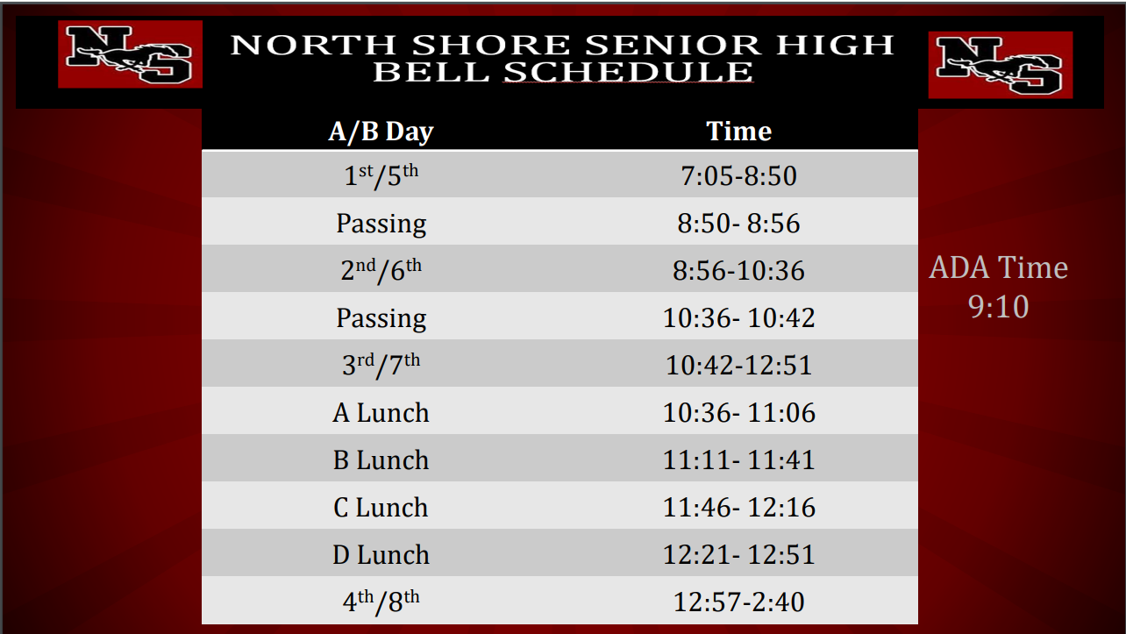

**Can my Mustang leave for lunch?**

*North Shore is a closed campus. Mustangs may not leave for lunch unless they are checked out by their parents/guardians. Mustangs are also not allowed to receive lunch deliveries in the main office.*

**How do I know when my Mustang attends 1st-4th periods or 5th-8th periods?**

*1st-4th period classes meet on Mondays and Wednesdays. 5th-8th period classes meet on Tuesday and Thursdays. Fridays alternate between 1st-4th period and 5th-8th period.*

**My Mustang has a scheduling issue. What should I do?**

*Email your child’s counselor.*

* 11th Grade A-F (Lekeitha Johnson) [lljohnson@galenaparkisd.com](mailto:lljohnson@galenaparkisd.com)
* 11th Grade G-N (Andrea Jones) [ajones1@galenaparkisd.com](mailto:ajones1@galenaparkisd.com)
* 11th Grade (O-Z) (Kristen Watts) kwatts@galenaparkisd.com
* 12th Grade (A-F) (Tabitha Sapien) [tsapien@galenaparkisd.com](mailto:tsapien@galenaparkisd.com)
* 12th Grade (G-O) (Pamela Wallace) [pwallace@galenaparkisd.com](mailto:pwallace@galenaparkisd.com)
* 12th Grade (O-Z) (Sherronda Galloway) [sgalloway@galenaparkisd.com](mailto:sgalloway@galenaparkisd.com)

**When will my student be able to participate in extracurricular activities?**

*Most extracurricular activities will begin on August 30, 2021. Please note that all Mustangs must exit the building and will only be allowed back in at 2:50 PM if they have a pass from their club sponsor to enter the building. Students are able to reenter the building from the South Side doors along Mustang drive for after school activities.*

**How do I add money to a cafeteria account for my Mustang?**

*Whereas lunch is free everyday for all Mustangs, we understand that some may want additional servings or meals, if so, you may create an account and add money to the account by clicking on the following link:* [*https://www.schoolcafe.com/*](https://www.schoolcafe.com/)

**Where can I access the bus schedule?**

*You can access bus information by clicking on the following link:* [*http://www.infofinderi.com/ifi/?cid=GPI5D7D5W0I5*](http://www.infofinderi.com/ifi/?cid=GPI5D7D5W0I5)

**Where can I access the North Shore Dress Code?**

*You can access the dress code information by clicking on the following link:*

[21-22 E,M,HS Dress Code_English.pdf](https://drive.google.com/file/d/1WQEGe2KSzMhRsCNK-KU00DnwLc3otg3Y/view)

**___________________________________________________________**

**Clubs and Organizations Announcements:**

Students who participate in afterschool programs, must be with their sponsors at all times. In addition, Mustangs must exit the building at the end of the school day and are only allowed to reenter the building at 2:50 PM if they have a pass to their organizational meeting or practice.

_____________________________________________________________________________

**Important Dates:**

08/09 - Parent/Student Orientation- 6PM NSSH Gym

08/11- First Day of School- 7:05 AM

09/05 - Labor Day Holiday - No School

09/12 - Summer Graduation, 5 p.m. - NSSH Auditorium

09/22 - NSSH Blood Drive

**Have a Great Mustang Day!**