Jacinto City Elementary
PK-4 School Supply List
2024-2025
1 Clear or Mesh Backpack
6 CRAYOLA Crayons 24ct
1 CRAYOLA Classic Thick WASHABLE Markers
1 FISKARS 5" Blunt Tip Scissors
1 Crayola Crayons JUMBO
1 Crayola Colored Pencils
1 Prang My First Ticonderoga box of 4 JUMBO Pencils
1 12X18 50ct Asst. Colored Construction Paper
1 12X18 50ct White Drawing Paper
1 Crayola Washable Kids Paint 2 oz. / 10 pack
2 Elmer’s Glue 1.25oz MINI SIZE
6 Elmer’s Glue Sticks JUMBO size
1 K-2 Grade Primary Composition Notebook
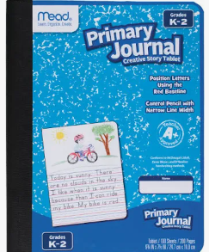
2 Packs of Play Doh (Assorted Color Packs)
1 Crayola Watercolors
2 Hand Sanitizer (Jumbo)
1 Headphones (on the ear adjustable band with wire)
2 3-Ring Pencil Pouch
1 Orange Poly (plastic/vinyl) Pocket Folder (NO Brads)
2 Baby Wipes Soft Pack
1 ½” Binder
1 Snack Size Ziplock Bags
1 Gallon Size Freezer Ziplock Bags
1 Quart Size Ziplock Bags
2 Facial Tissue

